Woking Association of Neighbourhood Watches

Managing your Watch using the Neighbourhood Alert systems

A guide for co-ordinators

Martin Stilwell
Woking MSA and Surrey Neighbourhood Watch
Communications Administrator

April 2017

Email: wansec@wanw.org.uk
Table of Contents
1 How does the system work? 3
1.1 What systems do you see? 3
1.2 Registering on the system 3
1.3 What can everyone who registers do? 4
1.4 What if the co-ordinator does not want to register? 5
2 Member Emailing 6
3 Getting alerts from another place in the UK 12

How does the system work?

What systems do you see?
All registrations are held in a UK-wide central system called Neighbourhood Alert (NA) that is managed by a company called Visav (pronounced “Visa-V”). User logins, passwords and preferences are held in here and all emails that are sent come from this system.
As a co-ordinator you can log into your account and change your user details and manage the people in your Watch. To log in many people have two options. The first is go to www.ourwatch.org.uk and at the top right hand corner click on Menu, and then at the bottom right hand corner you can sign in. The second, a short cut, is to go to www.ourwatchmember.org.uk where you can sign in directly. If you have forgotten your password you can recover this by clicking on ‘Forgotten your password?’. The borough administrator cannot see your password, or reset it for you.
The public can see what watches are in their area by accessing www.ourwatch.org.uk or the Surrey/Sussex public system called “In The Know” – www.intheknow.community .

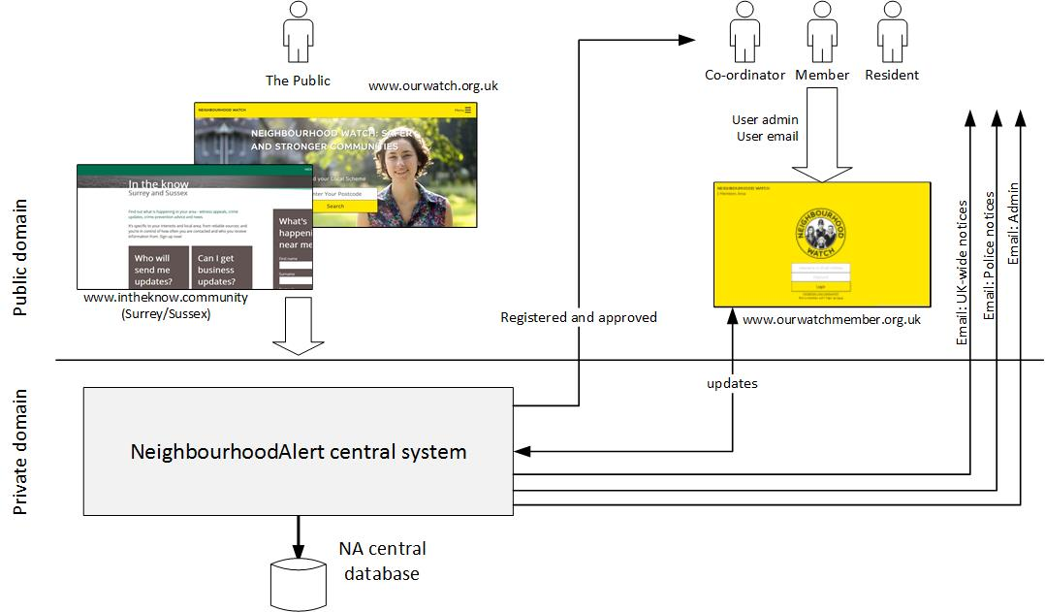

Registering on the system
Users can register via a number of routes:
- Ourwatch.org.uk (the NA “shop front”)
- Surrey/Sussex InTheKnow (ITK) front screen (the Police force subset of NA)
- An NhW microsite such as www.sussexnwfed.org.uk.
These websites allow a new registrant to do a number of actions:
- Simply register on the system and link to a number of organisations and so receive their notifications. Default organisations are usually the Police, Neighbourhood Watch and the Fire Service.
- Register on the system and link to an existing Scheme as a member or coordinator (a “scheme” is what the system calls Watches).
- Register on the system and create a new Scheme.
There is a hierarchy to the registrations that is useful to know:
Resident >> Member >> Co-ordinator >> Lead Co-ordinator
Everyone who registers on the system becomes, by default, a Resident. When the registration has been finished, the system will immediately send you an automated email with a link that must be clicked to validate your email address. This is standard security practice on many registration systems. If the registrant does not respond to the email within 14 days their account will not be activated and they will not receive any emails or notifications. Note that a failure of the resident to acknowledge the validation email could be the result of them typing an incorrect email during registration, or because the automated email has gone into their spam/trash mailbox. In the case of suspended users, it may be worth emailing the resident directly to check the validity of the email address and whether they have noticed the automated email. If the email was treated as spam they need to be advised to set their filters to allow emails from alert@neighbourhoodalert.co.uk.
The Resident can remain on the system as such and will receive emails and notifications from county, local Police and Neighbourhood Watch UK-wide. However, if that resident wants to become a member of an existing Watch they can join it when they register, or log in and join to that Watch later. The Resident then becomes a Member.
Residents and Members can set up a Watch. This requires a minimum amount of information such as the number of houses in the Watch. The Resident/Member then gets promoted to being a Co-ordinator. This Watch will be self-declared until approved by a local Surrey Neighbourhood Alert administrator. This authorisation used to be carried out by the Police in Surrey, but they are no longer doing this. Therefore, the borough administrator will be in contact to discuss the new Watch and to gain assurances that the co-ordinator has set up the Watch properly and will manage it well. Note that in Sussex there is a slightly different system. To become approved your local administrator will contact you and ask you to complete a simple form giving permission for police to carry out a basic records check. Once this has check has been carried out by police then the administrator will advise you that you have been approved. Once a co-ordinator has been approved then the administrator will record this fact and then if you search for your scheme on www.ourwatch.org.uk your scheme will be marked with a yellow circle rather than a white one.
Note that every Watch has a Lead co-ordinator. Watches with more than one co-ordinator will have a Lead Co-ordinator and one or more co-ordinators. The system allows for deputy co-ordinators but we ask you not to use that role as they may not receive all the communications sent to the other co-ordinators.
One piece of terminology you need to understand is that we all call them Neighbourhood Watches, but the underlying Neighbourhood Alert system calls them Schemes. Just be aware of this. If you see the word “scheme”, think “watch”.

What can everyone who registers do?
When the auto-email is responded to, the system displays the Membership Administration Area page where all the options are available. At any other time you can log into your account either via OurWatch: www.ourwatchmember.org.uk; via InTheKnow: https://www.intheknow.community/ - click on the “sign in” option, top right; or via a microsite if one is available for your county. All systems give you the same features to edit and maintain your account, and send emails. Note that you will only be able to log in via InTheKnow if that is where you first registered.
Once logged in, the options you have are:
- Edit your details >
- Configure who can see you >
Review and configure which Information Providers can see your details and communicate with you...
- Add your workplace or business >
The Neighbourhood Alert network enables you to add your business details to your account if you would like to...
- Message settings >
To configure how and when you would like to accept messages please edit your message settings...
- Your Interests >
To tell us a little more about your interests and any Watch scheme involvement...
- Unsubscribe Options >
If you are considering leaving the system, please consider first that you are able to filter and control all of the...
- Report Information >
Neighbourhood Alert does not currently have a information reporting agreement with your local Police force...
- Previous Reports >
View reports that you have previously submitted...
- Email Sharing >
Share your messages with people you know that aren't on the system...
- Previous Messages >
All messages relevant to your area will be stored here for your perusal...
- Scheme Admin >
Find your local Neighbourhood or Home watch scheme or setup a new / existing scheme...
- Your Business >
To find your business please enter your business name and the postcode of this business and...
- Crime Statistics >
Displays street level crimes that have occurred within a one mile radius of your registered address. Note that this data is historical and taken from the Police.uk website.

Mapping a Scheme
When a co-ordinator registers on the system they have the option to map their scheme. Not all co-ordinators do this mapping, but it is quite important to do as it tells potential new residents what streets or part of streets you cover, and even down to specific houses if you map it accurately. An existing map can also be redrawn at any time. Log into Ourwatch or InTheKnow.
Log into Ourwatch via www.ourwatchmember.org.uk. Scroll down to the “Scheme admin” option and select. If you have mapped your scheme you will see the map. To change it scroll to the bottom of the page and select the “Edit your scheme name, map and description” option. To suggestion is to “Clear points”, “Add points”, hover over the map and redraw by clicking at the boundary points, and drag the cursor down the “Save points” to save it (the instinct is to double-click to finish, but this does not work – drag to “Save points”). You can always retry if you are not happy with the map.
Log into InTheKnow via https://www.intheknow.community/. Scroll down to “Manage your scheme membership”, scroll down to “Edit your scheme name, map and description. The mapping facility in ITK is a little different than for Ourwatch describe above but the principles are the same. There are 3 icons to “draw”, “edit” and “erase” the map. Clicking “edit” allows you to select points and drag them. Double-click to save the new map. When you are satisfied with all the details, save changes at the bottom of the page.

What if the co-ordinator does not want to register?
It is accepted that some co-ordinators will not want to register on any system and maintain their Watch the more traditional way of passing information to residents via notices passed through letter boxes, and/or via telephone. Note that the co-ordinator is expected to have email as that is the default method the Police use to forward notices.
There is no problem with co-ordinators continuing to operate like this but they will be, more and more, at a disadvantage as both the authorities and the residents become more reliant on IT for information passing.
By using Neighbourhood Alert systems to maintain registration details and manage emails, co-ordinators will be benefitting from developments in the systems to improve and streamline the passing of information between authorities, co-ordinators, and residents.
Two key features of using Neighbourhood Alerts systems are the emailing facility and the ability to add an Alert area to receive messages from somewhere else in the UK where, say, an elderly relative lives. These options are covered in the next two sections.

Member Emailing
All registrants, whether Residents, Members or [Lead]Co-ordinators, have access to quite powerful emailing facilities. As co-ordinators you can, of course, continue to forward Police and Neighbourhood Alert emails from your own personal mailbox, but this built-in email facility is useful for larger Watches and allows you to set up sub-groups.
For most co-ordinators, the best option is to generate a Group of people whose email address is known. The obvious best use of this is to be able to forward Police and Neighbourhood Alert emails to neighbours who are not registered on the system; or to friends, relatives, etc. The co-ordinator needs to know the recipient email address, of course, but it does mean that emails can be forwarded very quickly. Even better, any of those recipients can choose to unsubscribe from the Group and so prevent the facility being over used. To forward an email the recipient simply clicks the “Share this message” option at the bottom of any Neighbourhood Alert email. No need to even log in.
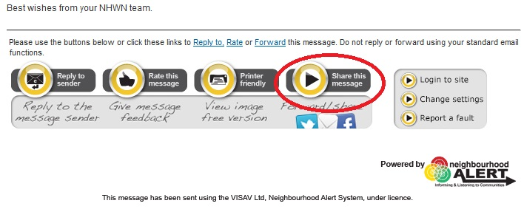
In the Administration Area page, one of the options is “Emailsharing”. The examples below are taken from the OurWatch system, but they are also all there in the InTheKnow system
The email sharing options allows co-ordinators to email all registered members in their Scheme and to set up a Group of email addresses which is useful for forwarding emails to residents who are not Members in their scheme. The first step is to retrieve existing recipients/groups, or set up new ones.
The email sharing link can be from the main screen or the menu drop-down
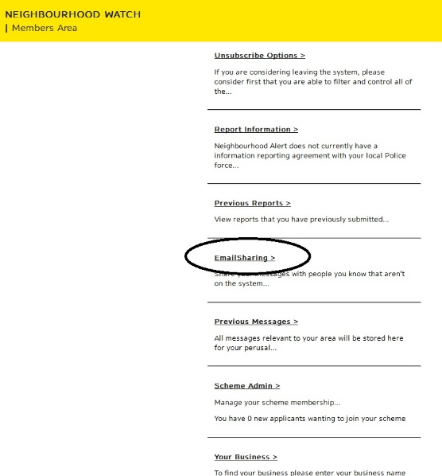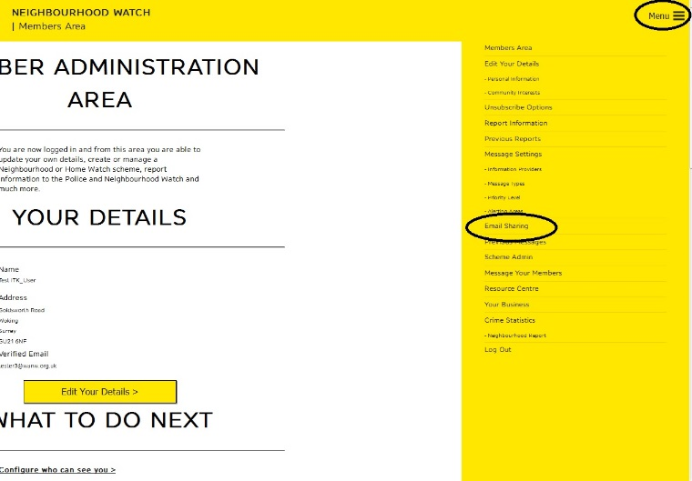
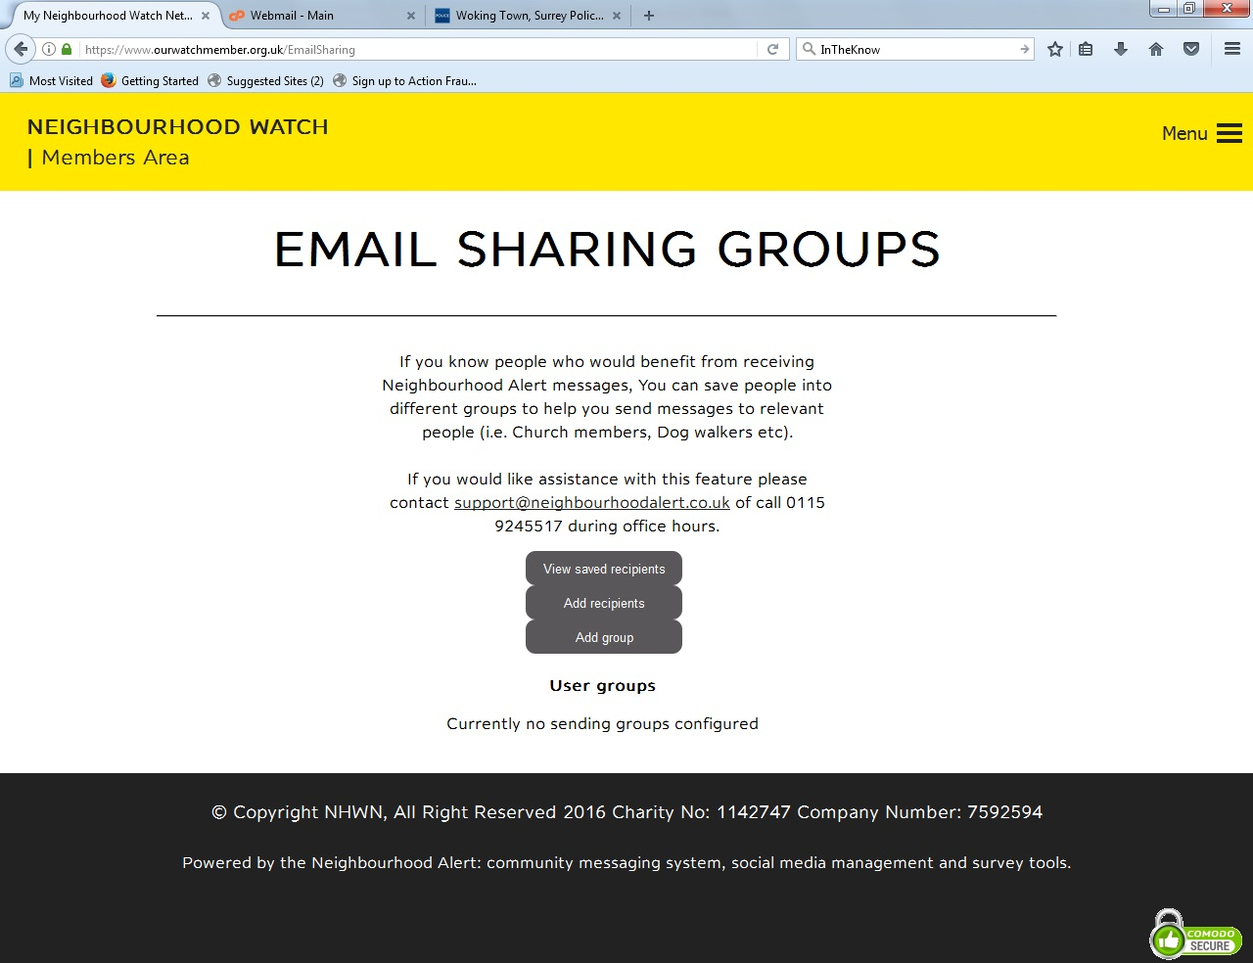
The first step is to add neighbours and friends into a Group. Create the group by clicking on “Add group” above.
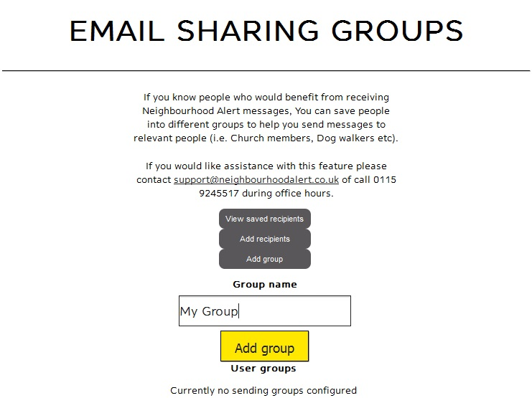
Give it a name and click “Add group” yellow box.
Next click on “Add recipients” option and add one or more neighbours and friends. For each one tick the group you want to put them in and “Add recipients”.
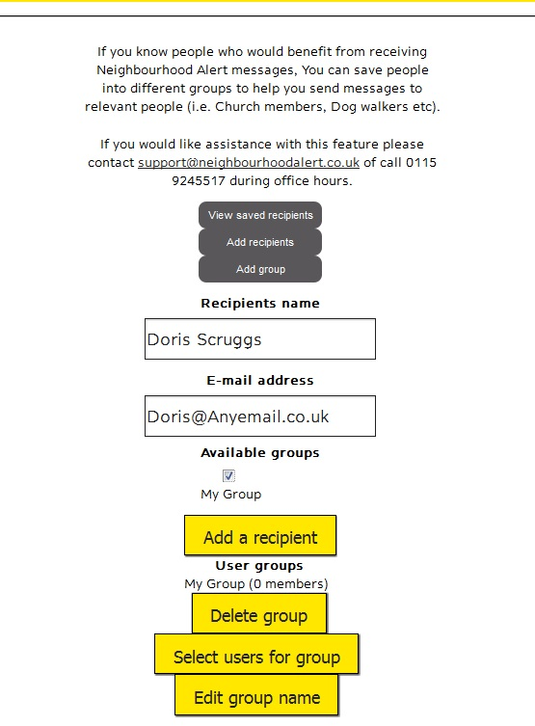
You can add more users or remove them at any time.
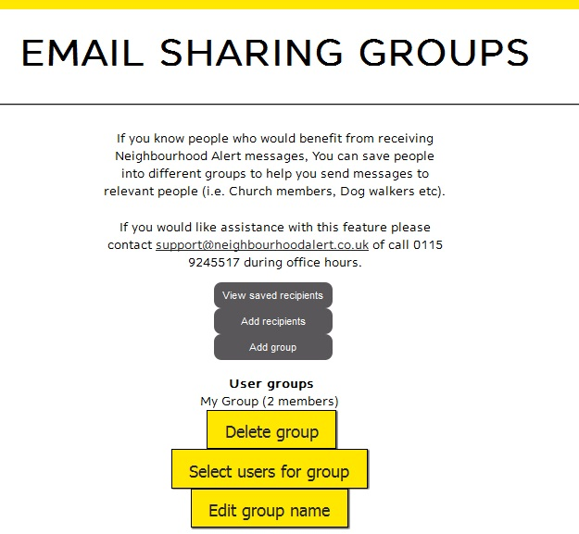
Now, when you forward an email from Neighbourhood Alert, you can select this group or select other individuals outside that group. Below is an example (note that for Surrey, the emails always say they come from “In the know”). Click on the “Share the message” link.
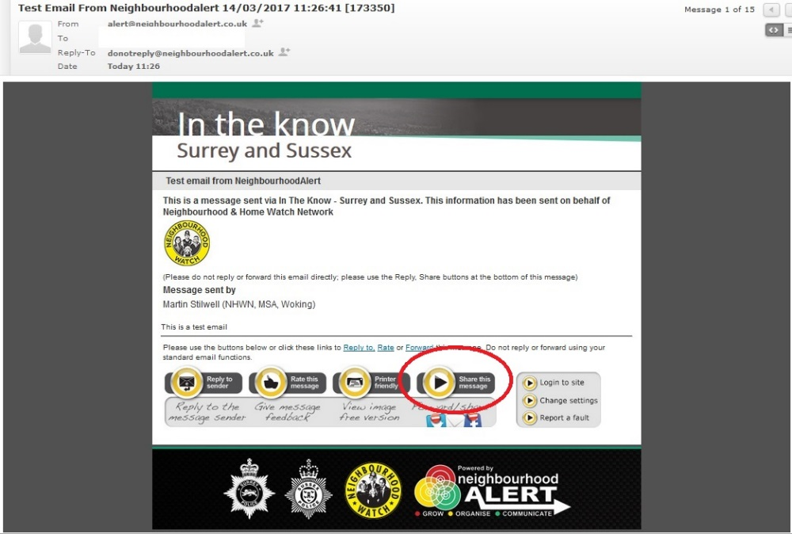
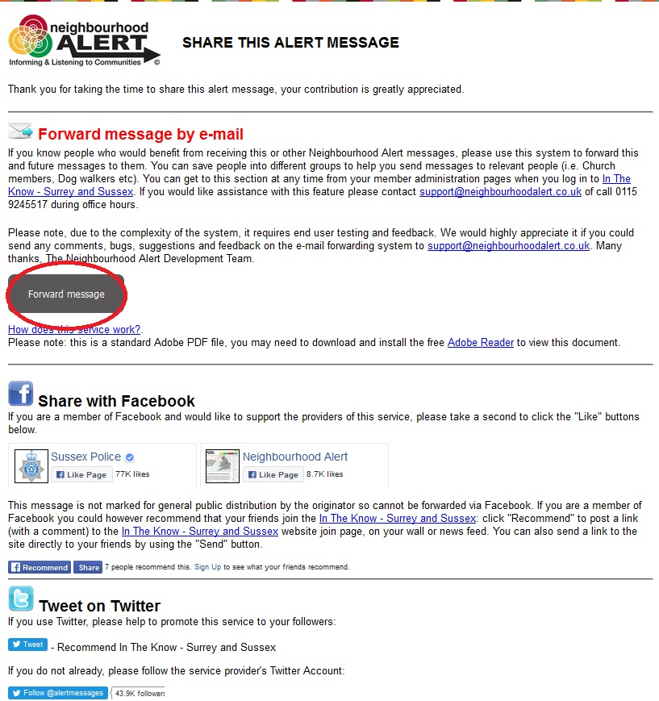
Forward the message.
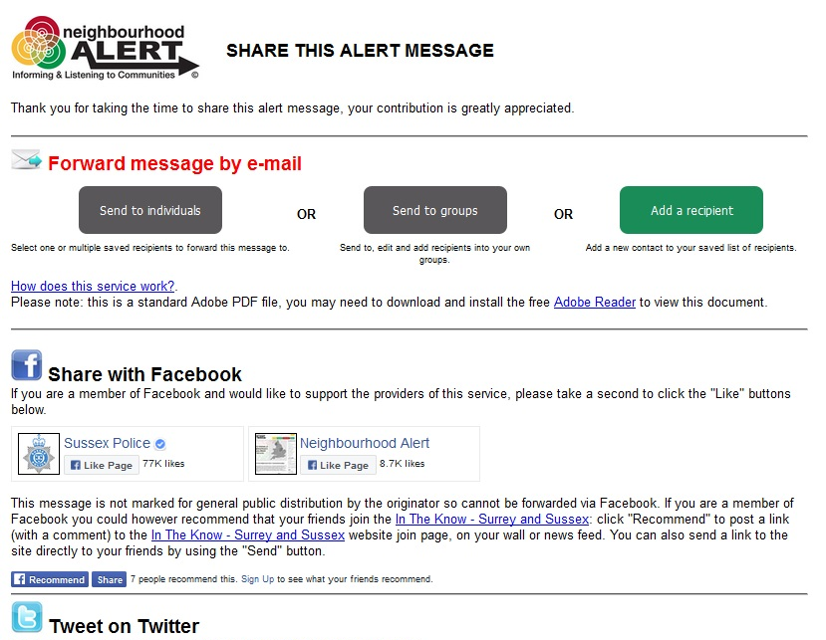
Send to individuals (you will add emails manually), or Send to Groups, or Add a recipient to a List of existing recipients. The example below has the users in a Group selected and note that you can still add recipients. Click on the Send and the email goes out straight away.
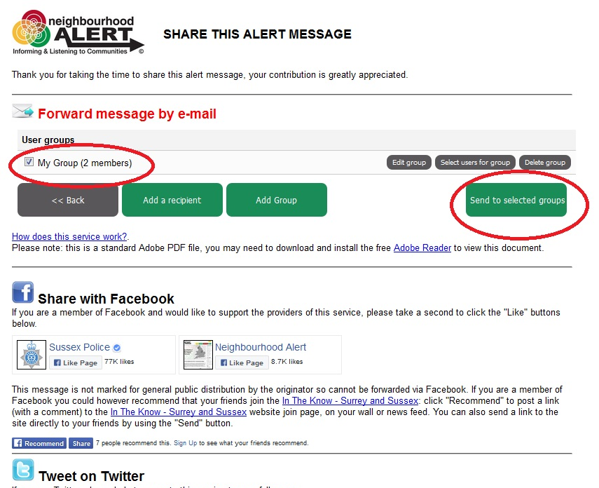

Getting alerts from another place in the UK
This facility is aimed at receiving Alerts for where elderly parents live, or where your business might be located. You remain a member/co-ordinator at your own registered address, but you additionally receive any Alerts from the other area.
Using OurWatch as the example, you click on the menu icon top right and there is a link to “Alerting areas” in the drop-down.
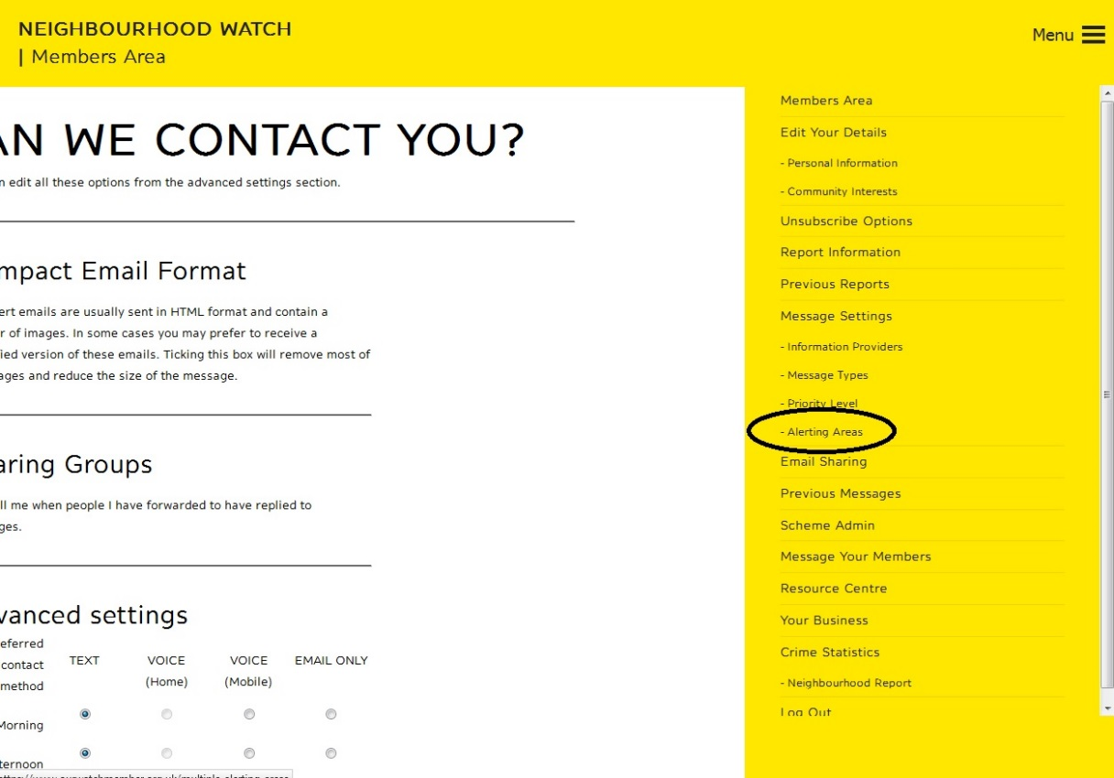
Note in the example below I have the usual “Home” alerting area and another “Relatives” area already set up. The example will add a third alerting area. From that option select “Add a new area”.
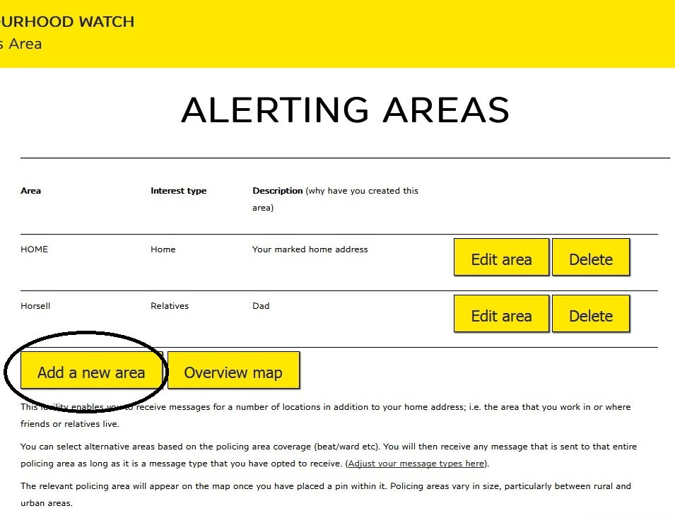
Follow the clear instruction on the next screen. Note that you should select the interest type as “work”, “relatives” or “other”. Place the cursor on the street where you want the area to be centred, and click the mouse. NOTE THAT THERE WILL BE A DELAY OF ABOUT 15 SECONDS BEFORE ANYTHING HAPPENS.
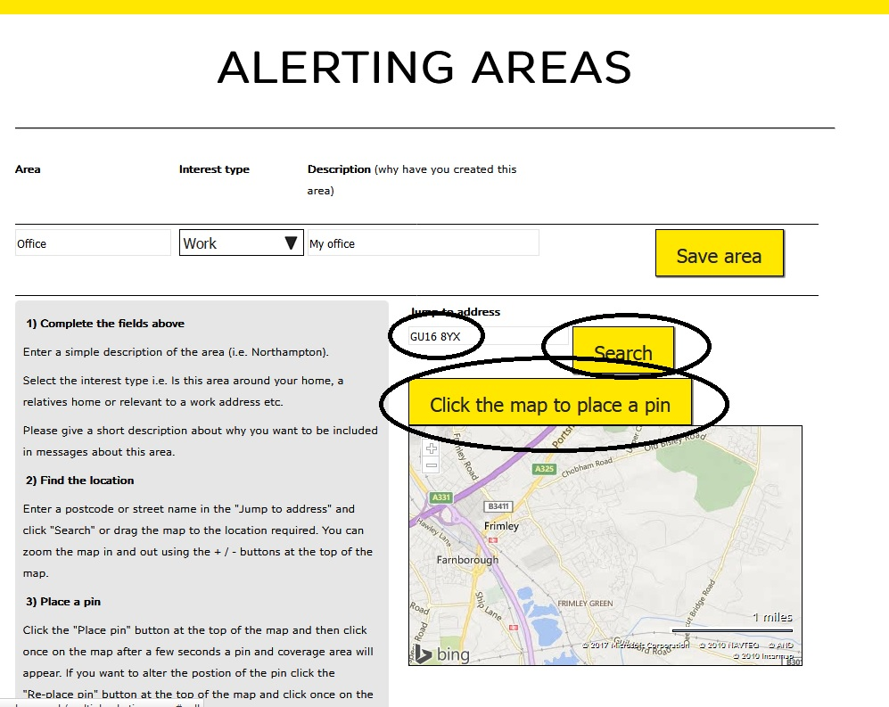
If the chosen location is not in an existing Watch area it makes no difference to the system, but you will only receive borough-level messages. Note that the pin can be located at any address in UK.
When the pin is displayed and you are happy with the location, click on “Save area”.
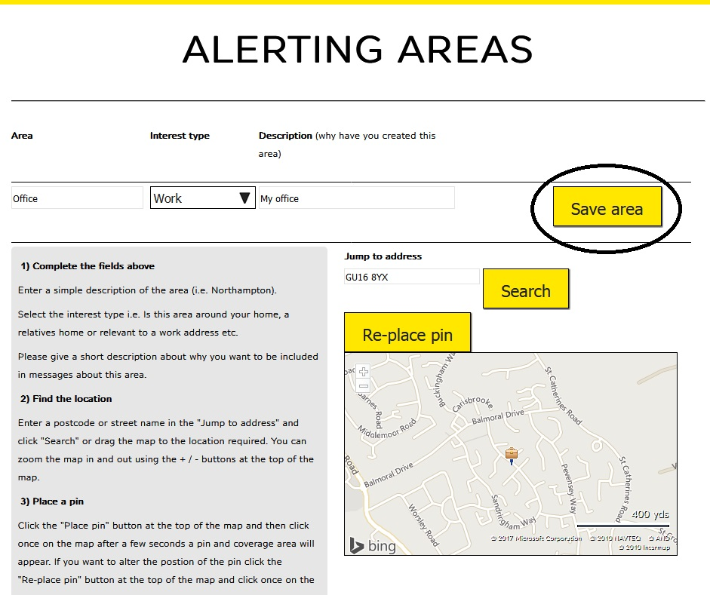
Below shows the additional alerting area set up. You can see your areas by clicking on “Overview map”.
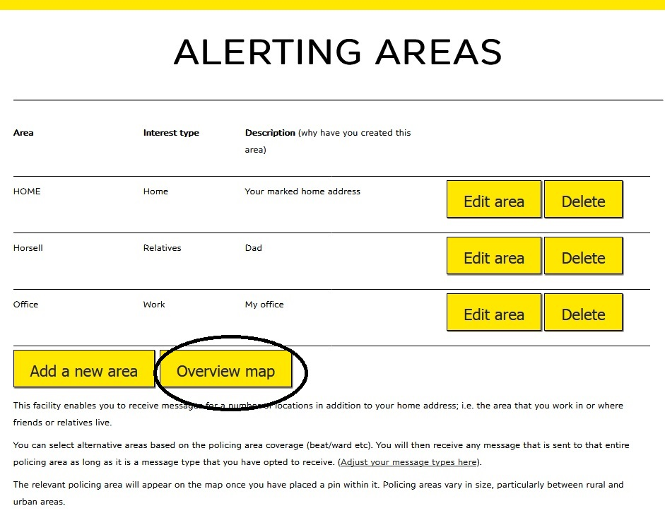
If your areas are wide apart you will need to zoom-out the map to see them. The coloured outlines are for the Police areas and not Watches (schemes). Note the not-very-obvious “Return to the map list” link to go back to the previous screen.

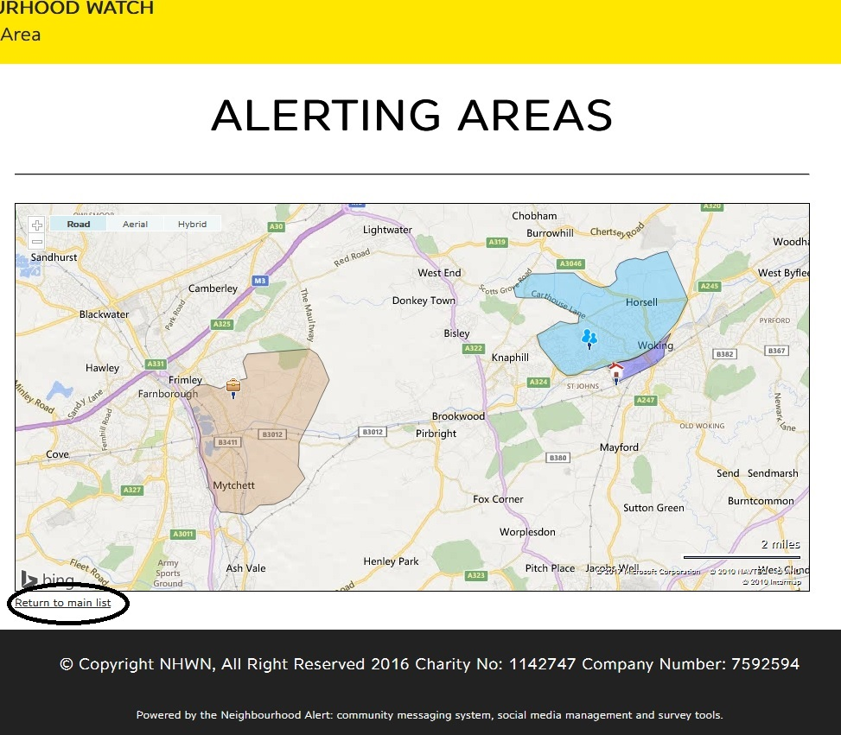
The co-ordinators and administrators in alerting areas outside your “home” one do not get notified of your interest in that area. However, you will now receive emails from the Police and other organisations along with everyone else registered in that location. You will not receive emails from a local co-ordinator unless that person spots your registration and adds you to their Group. If that is required it is suggested that you establish who the co-ordinator is and make yourself known to them during a visit. They could then add you to their email Group.
There is no reason why a resident cannot register on the system with the address of the elderly parent (say) but with their own phone number and email address. However, efforts need to be made to avoid having someone registered twice with the same email address, and so registering twice in the same borough is not a good idea. The above additional-area method avoids that problem.
Co-ordinators should note that where someone from outside their area legitimately registers to receive Alerts from their “patch” (where an elderly relative lives, say), they will appear as a Resident. The co-ordinator may like to make contact with the person registering (and the elderly relative) to ensure that all are aware of each other. The latter is important as the “outside” registrant may not be aware that their elderly relative is in an existing Watch. If the co-ordinator has any concerns over this “outside” registration they should contact their borough administrator.

